LCD screen Backlight LED External control circuit

Xavier Cano-Ferrer, George Konstantinou and Albane Imbert

The Making STP, The Francis Crick Institute

The present circuit is a PCB design based on the original concept published by Georg Keller (FMI Basel) and implemented by Martyn Stopps (NIMR, London & SWC) to optimize footprint and production. This work is only the implementation of the circuit in to a small PCB and a new version generating an inverting output that can be embedded inside of the original screen enclosure. The circuit provides the synchronization between each frame on the microscope acquisition and the flickering frequency of the screen back-illumination. The digital signal to the LED of the Toshiba photocoupler is generated in the two-photon acquisition software (ScanImage) from a modified line clock synchronized to the scanner DAQ board. This signal is transmitted to each of the four LED panels of the LCD display generating the desired current through the LED drivers BCR 421U E6327. The photocoupler also isolates the 5V control circuit from the 48V power circuit. The output current is modulated with an external resistor (Rext), in parallel with the Rint of the LED driver.

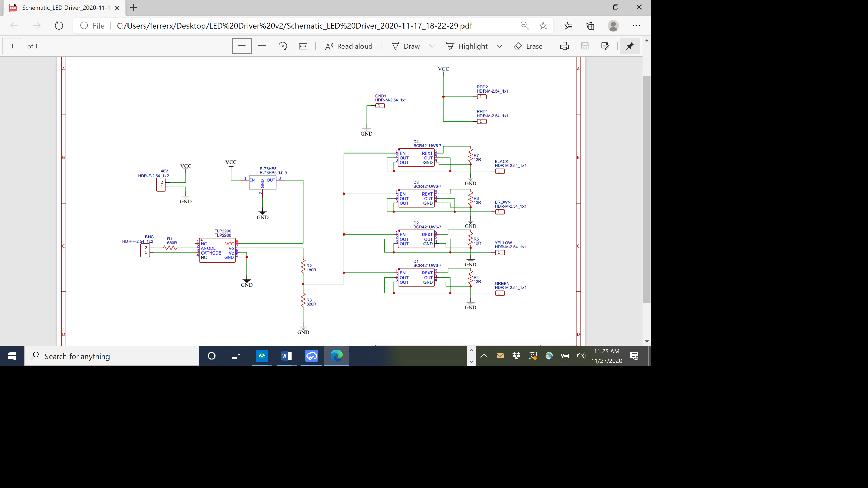

Figure 1: TLP2200 design based Schematic.

**Table 1: Bill of materials**

|  |  |  |
| --- | --- | --- |
| **Component** | **Units** | **Reference** |
| PCB CAM documents | 1 | Gerber_PCB_2020-11-17_10-26-37_2020-11-25_13-07-06 |
| Power supply - 48V, 48W | 1 | Farnell 1550930 |
| LED Driver (BCR 421U E6327) | 4 | Farnell 1791068 |
| DC converter 5V, 500mA (R-78HB5.0-0.5L) | 1 | Farnell 2440305 |
| Photocoupler TLP2200 | 1 | Farnell 1225845 |
| Resistor 8-15R 1/4W | 4 | - |
| Resistor 680R 1/4W | 1 | RS Components 223-2237 |
| Resistor 180R 1/4W | 1 | RS Components 197-8260 |
| Resistor 820R 1/4W | 1 | RS Components 223-2243 |
| RF Coaxial BNC | 1 | Farnell 1205963 |
| Power input Jack | 1 | - |

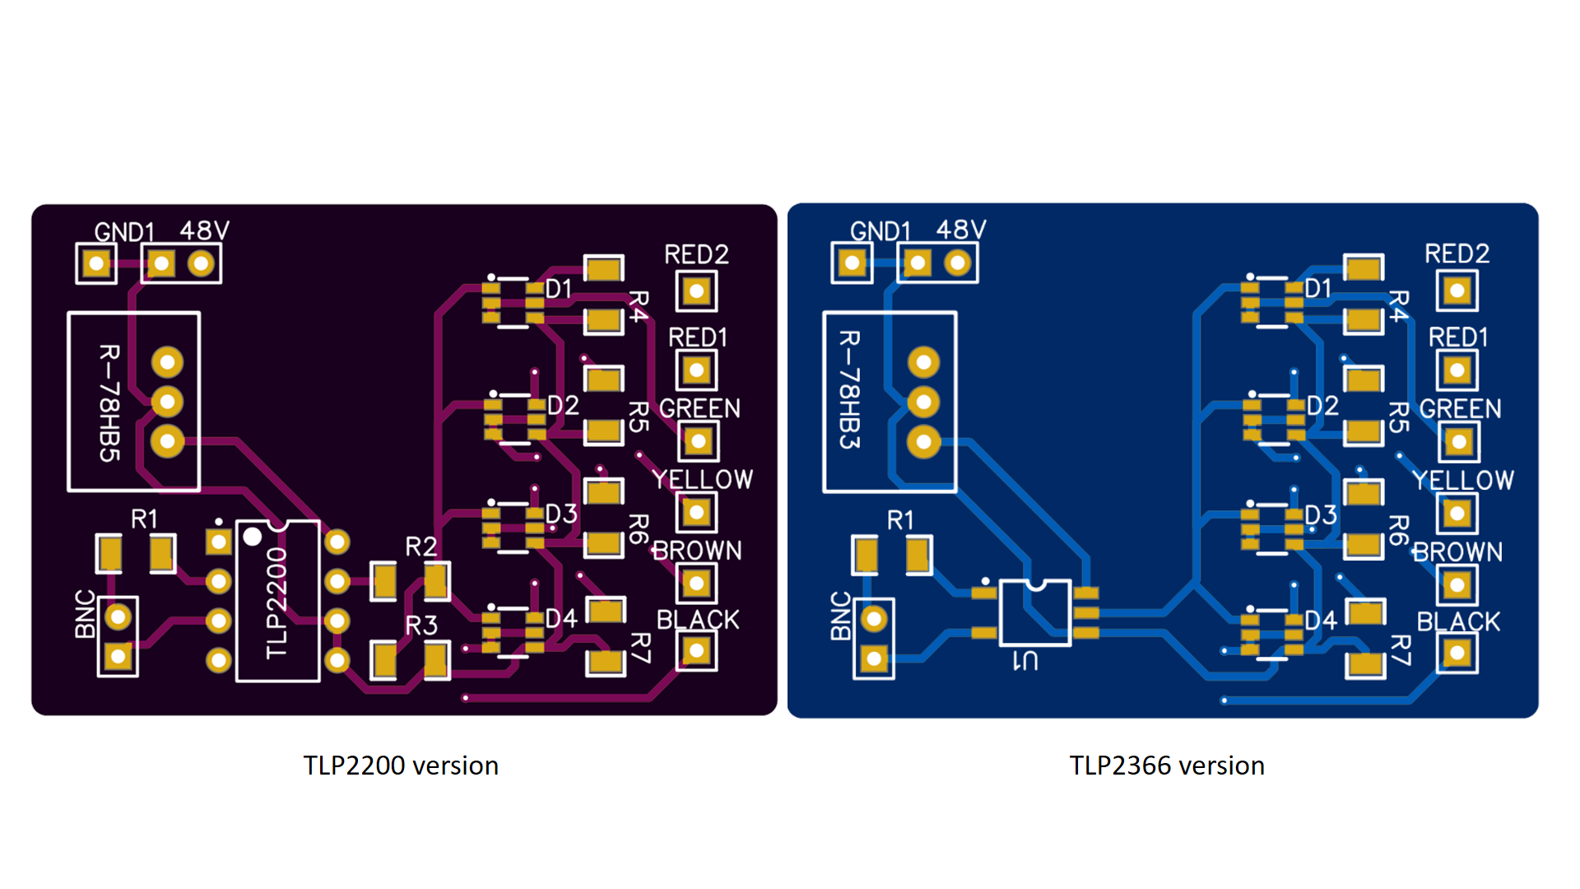

Figure 3:PCB design.

**Application example**

In the two-photon microscopes we worked with, every line in bidirectional scanning mode takes 62.5 us and we usually image for ~48 us. So that leaves us with ~14.5 us to turn on the monitor.

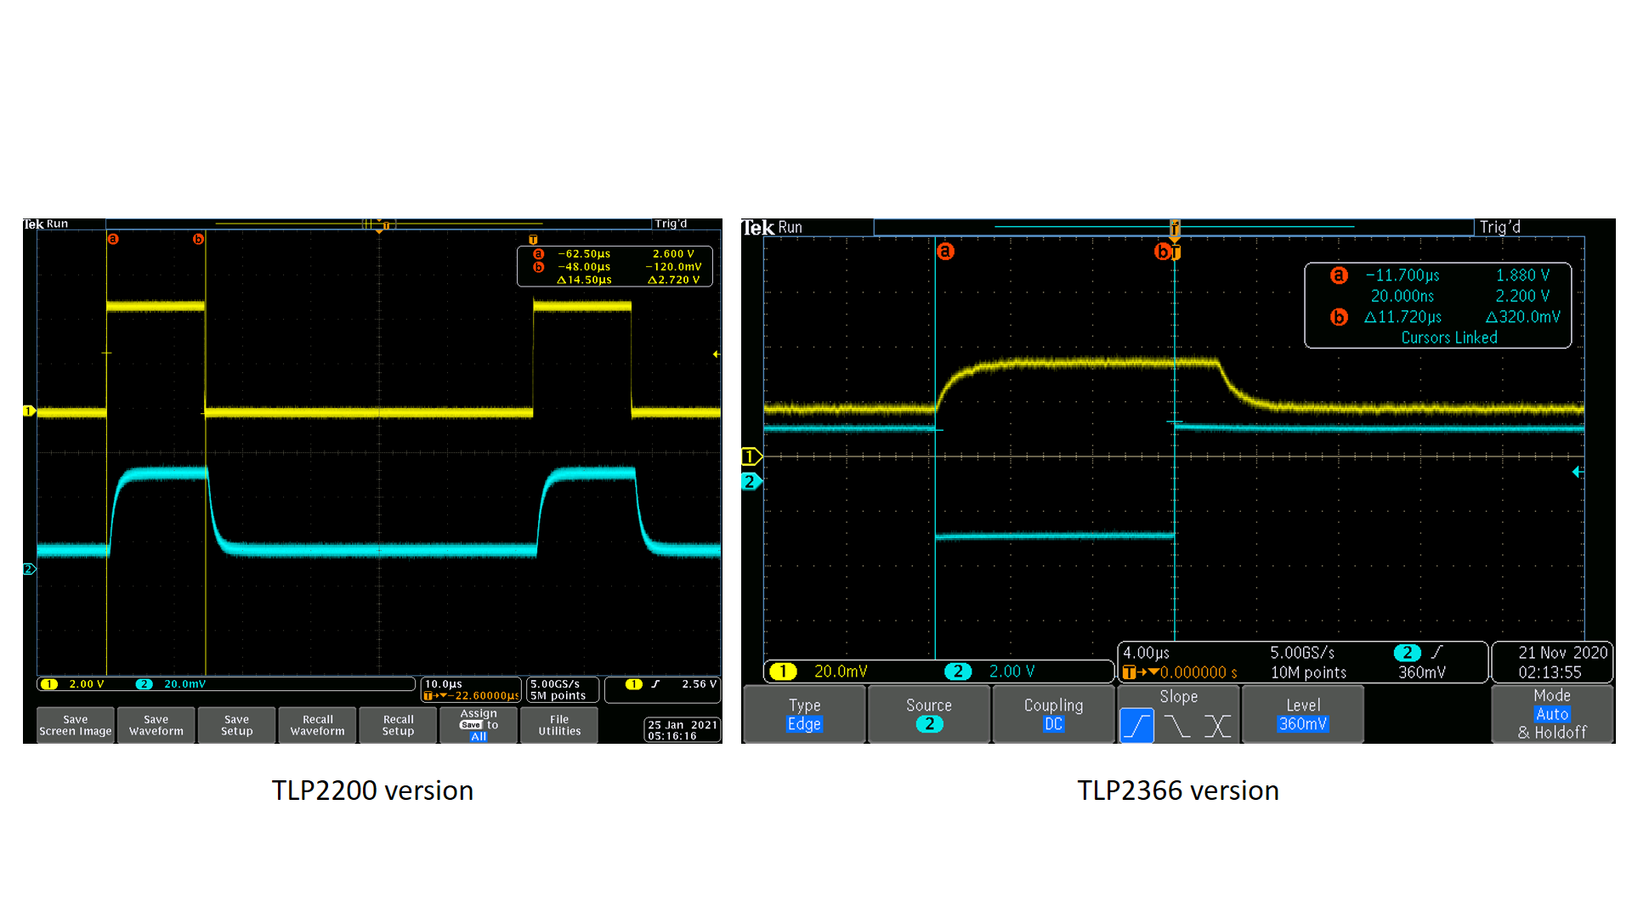

Figure 4: Response of the system measured in both cases with a Thorlabs Photodiode.

**Rext selection criteria**

The Value of the resistor associated on the output depends on the current demanded for your monitor/your brightness requirements. The screens we tested operate at 55-75 mA per channel. We recommend to measure these parameters in normal conditions and then choose the adequate Rext value according to the following figure from the Infineon BCR 421U datasheet.

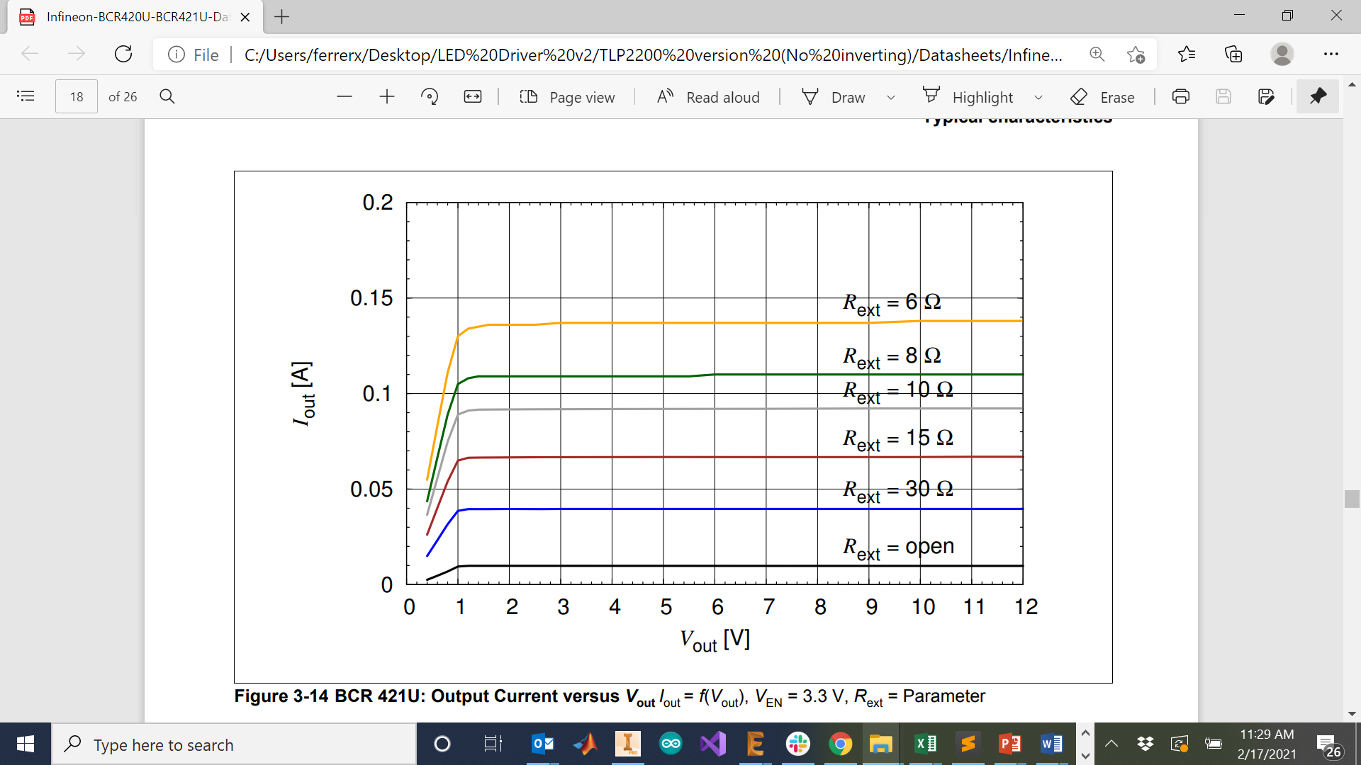

**Models of monitor tested**

* Dell U2415 (48Vdc, Iout = 72 mA , Rext = 12R)

**Installation example**

